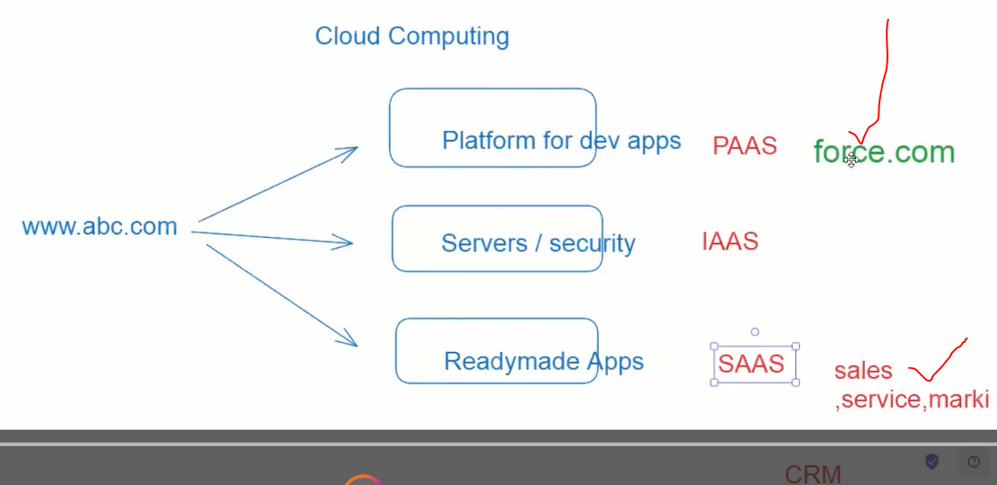

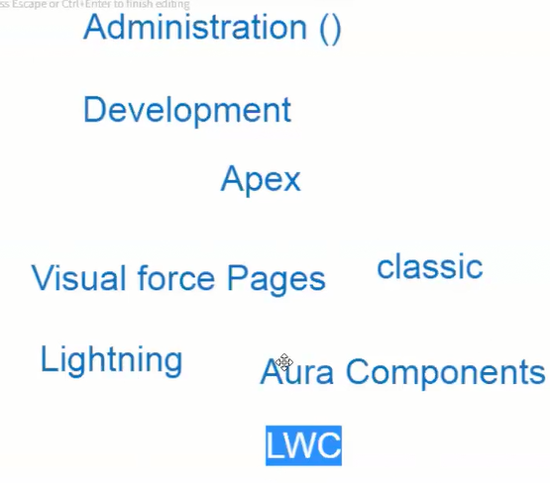

When you’re joining a company

The company provides you with the org needed to develop your code (dev)

Then it should move to the SIT (System integrated testing)

Then it should move to the UAT (User acceptance testing)

Then finally it will be moved to production.

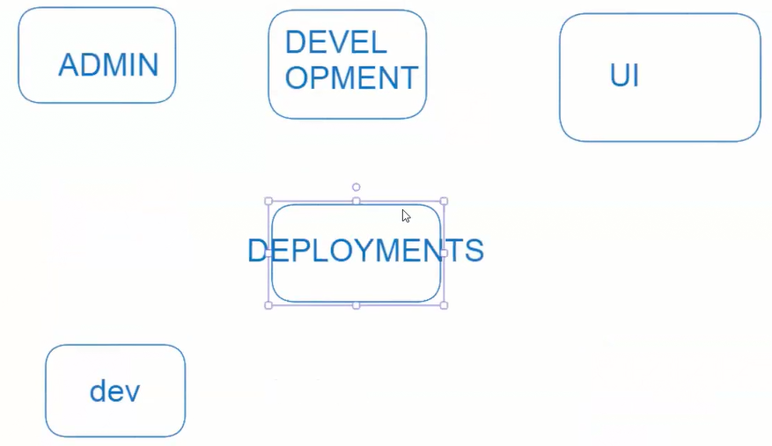

Here’s the username for your Developer Edition:  
[ravularakesh3845891@agentforce.com](mailto:ravularakesh3845891@agentforce.com)